
College of Business and Technology
School of Engineering and Information Systems
ETM 419.001
Dr. Kouroush Jenab
10.23.17
Emergency Room Quality
Group Project

Team Members:
Chase Schell
Kaleb Toller
Molom Mijid
Kyle Gilvin
Abdulmohsen Almulhim
Yousef Alhanun

Table of Contents:

Chapter 1: Introduction 3-5 pages - Chase -done
Pg. 2 Objectives
Pg. 3 Processes
Pg. 5 ER Department Positions: Key Element Breakdown
Pg. 8 Layout
Pg. 10 Admittance/Prioritization
Chapter 2: ER Process 3 pages - Everyone Pick a WBS
Pg. 11 Process Chart
Chapter 3: ER Strategic Management 6-15 pages- Kaleb & Kyle
Competitive Strategy
Components of Strategic Management
Creative Thinking in Strategic Planning
Chapter 4: SWOT Analysis 5-8 pages - Molom
Chapter 5: Mission Statement 1-2 pages - Mohsen
Chapter 6: Vision Statement 1-2 pages - Yousef
References APA format

Chapter 1: Introduction

The purpose of this report it to develop an ER process that utilizes everything we have learned about quality management to maximize the quality a consumer would receive by understanding things such as; the key elements of quality, objectives, mission, vision, and countless other tools that ensure or organizations success.7yygggt
Quality is defined in many different ways. But when viewed from a consumer aspect, quality can be defined as meeting or exceeding customer expectations. Total quality is the approach to doing business that tries to maximize an organization's competitiveness through continual improvement of the quality of its products, services, people, and environment.
Objectives
According to the Emergency Department Goals, Objectives and Teaching by American University of Beirut the purpose of establishing goals in an emergency room environment is to understand the basic principles of emergency medical services. Understand how to evaluate and manage an emergency department, and how to manage and prioritize emergencies (AUB, p.1).
Quality Management for Organizational Excellence Introduction to Total Quality written by David L Goetsch and Stanley B. Davis states that when developing objectives they should be broad and translate to the overall vision and mission in measurable terms (Goetsch, p.39).
When determining an organization's objective we should consider the following:
- Is the objective stated broadly enough
- Stated specifically enough that they are measurable but not in terms of numbers
- Each focused on a single issue or desired outcome
- Do they tie directly into the organization's vision and mission statement
- In accordance with the guiding principles of the organization
- And lastly, clearly show what the organization wants to accomplish
After consideration we determined that our ER should embody these broad strategic objectives:
- Create and sustain a professional environment, focused on high quality patient care and service.
- Practice timely service with all patients
- Demonstrate compassion, leadership, and respect in a professional manner
- Commitment to continuous improvement
Process
The National Center for Health Statistics states that in 2014 there were 45.1 emergency department visits per 100 people totaling 141.1 million visits (Center for Disease Control Prevention, n.d.). This means that the optimization and efficiency of an ER department is very important to supporting a community. So when developing a process or procedure it is key to analyze top level ER department in the country and benchmark ourselves to help improve and develop our own process.
For our scenario of developing a new ER department we can safely assume that we will focus on creating a positive culture of quality and continuous improvement. If we were to develop a strategy for an existing ER we would first:
- Understand the existing process of a top level ER department and their processes, tactics, and customer needs
- Analyze the current culture and set goals for improvement
- Communicate and develop a good relationship with all stakeholders/employees
- Obtain upper management commitment
- Baseline our own process, by completing time studies, surveys, and scholastic research
- ID and document our SWOT
- Collect and analyze data
- Create a action plan and set obtainable goal
- Implement our changes
- Monitor results and update our benchmarks to continue the cycle

We will base our ER process of the Children’s Hospital and Health Systems headquartered in Wisconsin it provides an overview of how a patient passes through the ER department, and will make a good template for us to follow

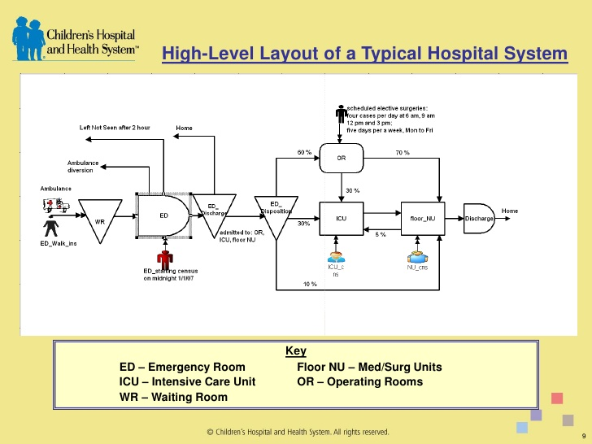
https://www.chw.org/
This is the process flow of our ER below.
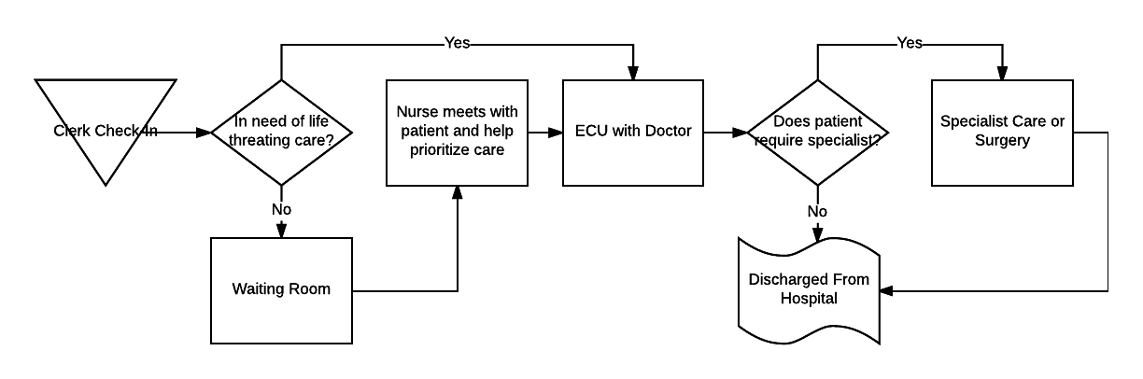

ER Department Positions: Key Element Breakdown

To ensure the success of our ER department we will have to focus on research and planning of the Key Elements of Total Quality. First we will have to understand what the Key Elements of Total Quality are;
Strategically Based: Comprehensive strategic plan that contains at least; vision, mission, broad objectives, and activities that must be completed
Customer Focus: External customers define the quality of the service provided. Internal customers help define the equality of the people, processes, and environments associated with the products or services.
Obsession With Quality: An organization must become obsessed with meeting or exceeding the defined quality. Never settling for just ok.
Scientific Approach: Hard data is used in establishing benchmarks, monitoring performance, and marketing improvements.
Long-Term Commitment: Understand that a culture or process does not change over night but can take years of dedication.
Teamwork: Every department and employee contributes to the overall quality of the ER
Continual Process Improvement: Continuous improvement of processes within a system are crucial to long-term success
Education and Training: Training is one of the best ways to improve people
Freedom Through Control: Employees need the freedom to make decisions and increase the ownership employees feel about decisions that are made
Unity of Purpose: Employees need to understand that their job is important and contributes to the success of the organization
Employee Involvement and Empowerment: Involving employees in ways that gives them a real voice
Peak Performance: When effectively practiced, total quality allows every aspect of an organization to operate at peak levels
(Goetsch, p.7-8)

By breaking down all the selected positions (Check in Clerk, Nurse, Doctor, Specialist in our ER and understand how we want those position to relate to the overall quality.

Check-in Clerk:
Strategically Based: Understand mission statement of hospital
Customer Focus: Soft skills. Quick Check in time. And making patient feel comfortable
Obsession With Quality: Setting time goals. I.e. no one have to wait longer than 10 minutes. Always improve relationship with community and performance.
Scientific Approach: Keep track of wait times. Benchmark themselves. Keep track of emergency types, for data collection purposes
Long-Term Commitment: Invest in the employees so they themselves feel satisfied, this will allow them to work harder and improve quality for everyone
Teamwork: Communicate well with nurses on condition on patient
Continual Process Improvement: Always look to improve check in process to become more efficient
Education and Training: Standardize procedures. And annual training seminars
Freedom Through Control: Clerk must have the power to improve processes if it can be made and have their voice heard in a meaningful way
Unity of Purpose: Understand that they are the first face when visiting the hospital, and have a real impact on the overall experience of the ER
Employee Involvement and Empowerment: Ability to voice/make decisions that affect the ER department
Peak Performance: Performance reviews, and surveys to help benchmark

Nurse:
Strategically Based: Understand hospital mission statement and commitment to quality
Customer Focus: Improve customer care through soft skills, and building relationship and strong performance
Obsession With Quality: Improve customer care through improvement of patient care
Scientific Approach: Implement procedures of company management strategy
Long-Term Commitment: Commitment to mission statement, and growth/improvement of hospital
Teamwork: Communicate well with front desk, and doctor on patient care and needs
Continual Process Improvement: Learn from mistakes, adopt new technology and listen to customer feedback
Education and Training:Certification programs be put in place, and continuing of traditional schooling
Freedom Through Control: Freedom to determine who needs immediate attention
Unity of Purpose: Job is extremely important to overall satisfaction of customer
Employee Involvement and Empowerment: Provide feedback and recommendations to fellow employees and management
Peak Performance: Customer feedback and performance review from management
Doctor:
Strategically Based: Doctor is the leader in the hospital, and need to exemplify TQM mindset
Customer Focus: Quick turnaround with visits and prescriptions
Obsession With Quality: Needs to always be improving their knowledge and skill based
Scientific Approach:Analyze current prescription market. And educate patients on use and health
Long-Term Commitment: Checkups with patrons at regular intervals
Teamwork: Communicate with nurses and specialist and build trust with one another
Continual Process Improvement: Learn from past mistakes. Accept new techniques and procedures. Try new things, and always improve customer experience
Education and Training: Research and seminars
Freedom Through Control: Prescribe what you think is best. Try new drugs if thought to be better
Unity of Purpose: Work with nurse and specialist to achieve customer satisfaction
Employee Involvement and Empowerment: Make changes to procedures and lead the hospital team
Peak Performance: Customer surveys
Specialist:
Strategically Based: Know their specific purpose and roll
Customer Focus: Professional to customer. Accurate knowledge, and the customer needs to feel comfortable
Obsession With Quality: Improve in their speciality
Scientific Approach: Research current technologies and keep up with the market
Long-Term Commitment: Chuck up therapy
Teamwork: Communication with doctor and customer
Continual Process Improvement: New tech and procedures
Education and Training: Research
Freedom Through Control: Control what patient needs to get healthier
Unity of Purpose: Work with doctor to achieve customer satisfaction
Employee Involvement and Empowerment: Help make decisions
Peak Performance: Customer feedback, additional training to improve performance

Layout
Because we are not limited by an existing ER, we are able to bring some of the best elements from multiple ER layout designs. According to Rethinking the E.R.: Hospital Emergency Department Plans written by Elizabeth E. Dickinson “the emergency department is fast becoming the hospitals new front door” (p.1) and because of the extreme need for regional medical facilities to be able to efficiently treat incoming patients. The article focuses on the; Decentralization, same-handed rooms, and going green of hospitals to improve their design and efficiency.
Decentralization is the process of removing storage areas and moving equipment closer to actual patients. For example many hospitals now store equipment outside of patient rooms, this cuts down on time for staff to retrieve equipment.
Just like standardization in manufacturing, same-handed rooms is designing so that every room in a hospital is the exact same, this is to allow staff to move intuitively which makes errors less likely (p.2).
Patient comfort is important to the overall quality of an ER environment. Going green focuses on adding greenery, natural lighting, furnishings to comfort patients of patients. But it also pertains to researching new eco friendly technology to save energy and resources (Dickinson, p.2)
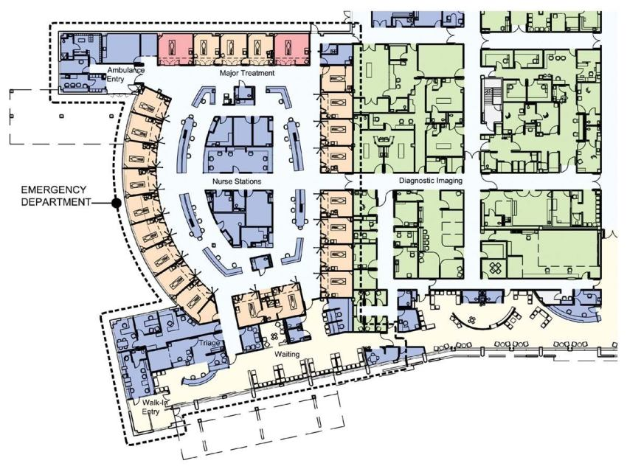
A plan of the emergency room shows the ring of private patient rooms (in orange) that encircles the staff area.
Courtesy of Francis Cauffman - Hospital Emergency Department Plans. American Institute of Architects
When designing our layout their will be many considerations such as how large does the ER need to be based upon the population it will service. Availability of land and budget. But that being said we would base our own design heavily on this layout courtesy of Francis Cauffman (above).

Admittance/Prioritization

Patients who are admitted into our ER will have varying degrees of medical needs and will need to be prioritized based upon resources, survival, and immediate needs. Edwina Jones RN, BSN E at The Baptist Health College teaches that there are 3 levels of priority that a patient must be categorized;.
Level 1: “these are threats to a patient’s these are immediate survival or safety and demand immediate nursing intervention. ABC’s (airway, breathing, circulation)”(Jones, p.8)
Level 2: “ concerns such as mental status change, things as mental status change, acute pain, acute urinary acute pain, acute urinary elimination, untreated medical elimination, untreated medical problems requiring immediate problems requiring immediate attention (diabetic needing attention (diabetic needing insulin) abnormal pathology lab insulin) abnormal pathology lab results, risks of infection, safety results, risks of infection, safety or security.” (Jones,p.9)
Level 3: “– those that do not fit those that do not fit into the above two categories into the above two categories such as monitoring for such as monitoring for medication side effects, lack of medication side effects, lack of patient knowledge, longer patient knowledge, longer-term problems with living activities, problems with living activities, etc.” (Jones, p.10)
We will rely heavily on the professional judgment of our nurse and clerk staff, when it come to prioritization. Our goal is that anyone that enters the hospital as a walk-in will be able to receive immediate attention, but due to factors such as resources and peak demands, we may have to make them wait.

Chapter 2: ER Process Chart

Process charts break down the individual positions into their; responsibilities, who they support, inform, methods, tools, and guidance. Along with a work breakdown structure.
Check-In Clerk
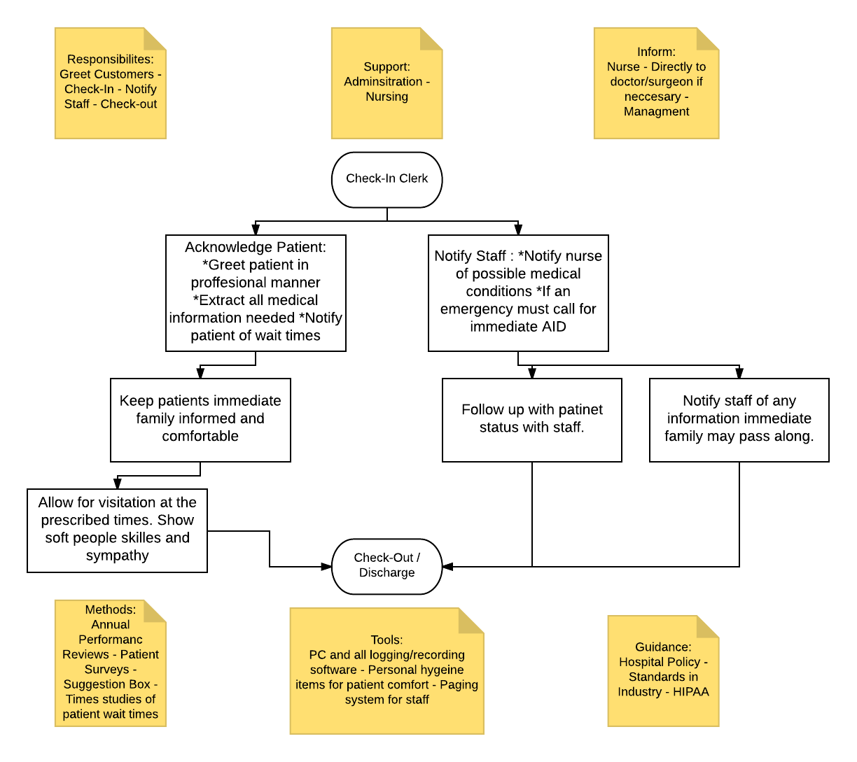

Chapter 3: Strategic Management

Competitive Strategy

Components of Strategic Management

Creative Thinking in Strategic Planning

Chapter 4: SWOT Analysis

We made some analysis in the organization’s plan which with the development of the strategic plan. Conducting the SWOT analysis to our ER project is mostly an organization’s internal situation which defined by its strengths and weaknesses.
By the way, SWOT analysis is a process that determines an organization's strengths, weaknesses, opportunities and threats. Specifically, for factors both internal (the strengths and weaknesses) as well as external (the potential opportunities and threats), analytical framework that assesses what an entity can and cannot do,. Using environmental data to evaluate the position of a company, a SWOT analysis identifies what assists the firm in accomplishing its objectives, and what obstacles must be overcome or minimized to achieve desired results.

Strengths are characteristics that form the basis of above-average performance potential of shares. Not only do strengths consider what a company does well, but why or how it does it well.For example, above-average revenue growth or superior margins are not in and of themselves strengths – it is the popularity of the products/service or the relative efficiency of a manufacturing process that represent the real strengths.
Here are some organizational Strengths such as our capability that gives a competitive power;
- Efficient technological processes.Its improved their design and efficiency for the decentralization, same-handed rooms, and going green of hospitals.Also we stored equipments outside of patient rooms, this cuts down on time for staff to retrieve equipment.Going green focuses on adding greenery, natural lighting, furnishings to comfort patients of patients
- High-quality services.Immediate survival or safety and demand immediate nursing intervention. ABC’s (airway, breathing, circulation).Concerns such as mental status change, things as mental status change
- Strong team management.We can safely assume that we will focus on creating a positive culture of quality and continuous improvement.Create and sustain a professional environment, focused on high quality patient care and service, Demonstrate compassion, leadership, and respect in a professional manner
- Strategic focus.Commitment to continuous improvement

Weaknesses release an organization from performing at its optimum level. They are areas where the business needs to improve to remain competitive: things like higher-than-industry average turnover, high levels of debt, an inadequate supply chain or lack of capital.
Here would be some competitive disadvantages that common organizational weaknesses;
- Time and labor intensive service process.Practice timely service with all patients
- Insufficient skills or capabilities in the workforce. Communicate and develop a good relationship with all stakeholders/employees

Opportunities and threats are external to the company. They represent things that could happen in the right conditions. Of course, that is a awfully broad guideline, so we can use the strengths and weaknesses above to narrow in on opportunities and threats that follow naturally from them. Here are some opportunities and threats

Chapter 5: Mission Statement

Chapter 6: Mission

References:

A. (n.d.). EMERGENCY DEPARTMENT GOALS, OBJECTIVES AND TEACHING . Retrieved October 17, 2017, from https://staff.aub.edu.lb/~webped/downloads/goals/emergency_goals.pdf
C. (n.d.). High Level Layout of a Typical Hospital System [Digital image]. Retrieved October 18, 2017, from https://image.slidesharecdn.com/shsasq2010presentationfinal-12768310626345-phpapp01/95/shs-asq-2010-conference-presentation-hospital-system-patient-flow-9-728.jpg?cb=1277115156
E, E. (2007). Rethinking the E.R.: Hospital Emergency Department Plans. American Institute of Architects. Retrieved October 19, 2017, from http://www.architectmagazine.com/design/buildings/rethinking-the-er-hospital-emergency-department-plans_o
Goetsch, D. L., & Davis, S. B. (2016). Quality Management for Organizational Excellence Introduction To Total quality (8th ed.). Hoboken, NJ: Pearson
Jones, E. (n.d.). Prioritization. Lecture. Retrieved October 19, 2017, from https://www.bhclr.edu/!userfiles/pdfs/course-materials/Prioritization.pdf
National Center for Health Statistics. (2017, May 03). Retrieved October 17, 2017, from https://www.cdc.gov/nchs/fastats/emergency-department.htm

